DAY 27: Investigate RDP Brute Force Attack
Summary: <place holder>
Following up the previous day, I also added ticket creation capability to the rule. However, today I’ll focus on investigating the RDP Brute Force attack rather than the ticketing system.
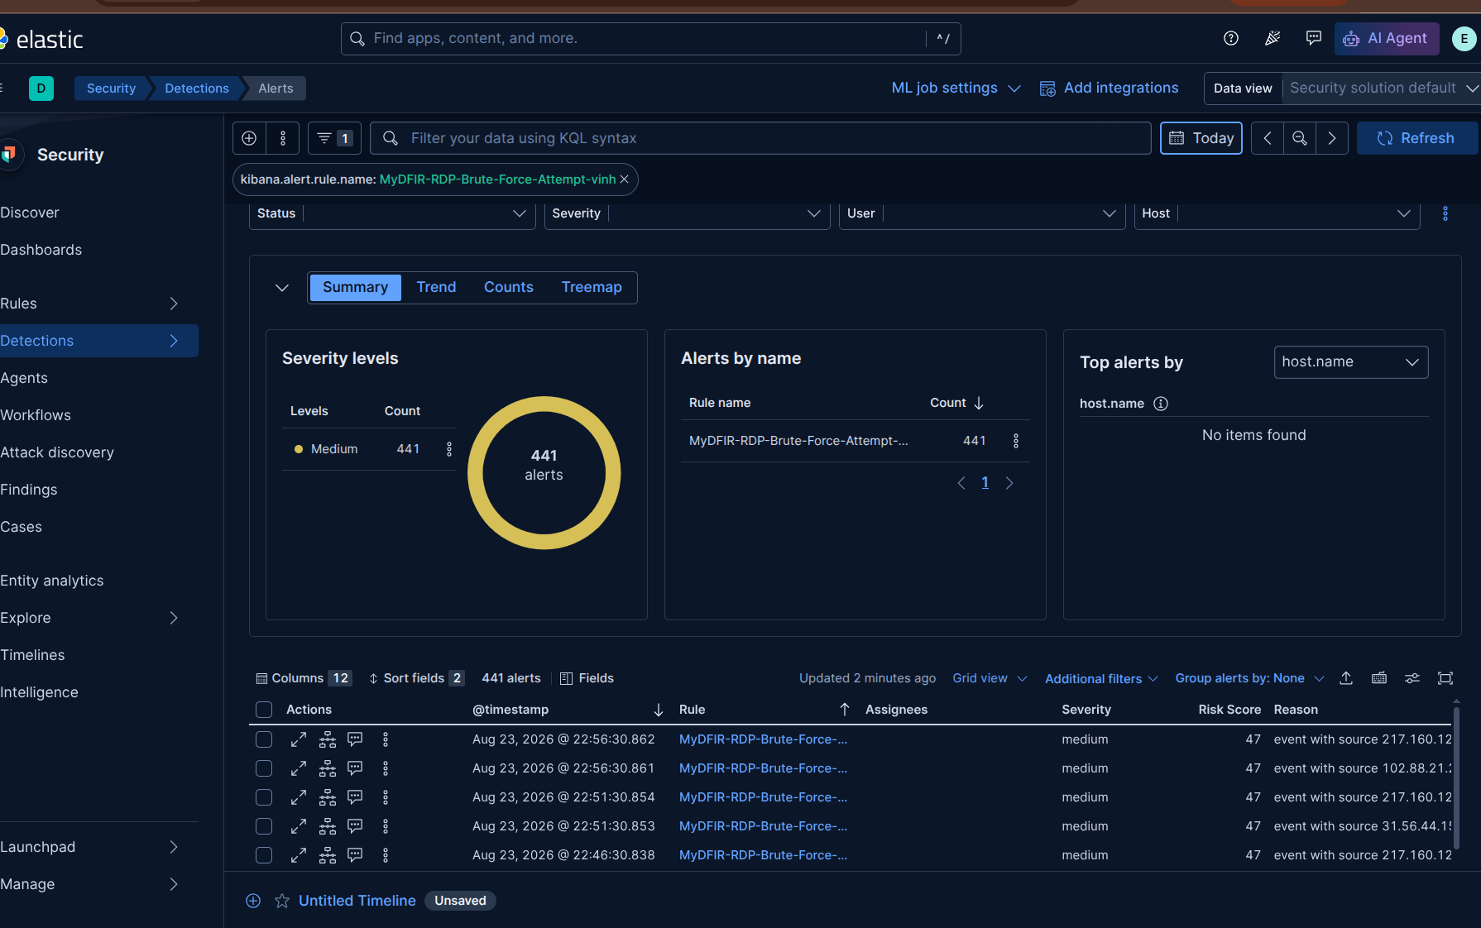
Figure 1: Alerts from RDP Brute Force detection rule
There are 441 alerts that were triggered by the RDP Brute Force detection rule in the Summary panel. At the bottom of this view, I can see a table of alerts, these alerts are sorted decreasingly from latest to oldest by default.
I will select the latest alert at the top of the table for investigation Similar to SSH Brute Force investigation procedure from Day 26, the first thing I’m going to do is extract the source ip of the traffic and search for it on IP reputation databases.
- source ip = 217.160.12.13
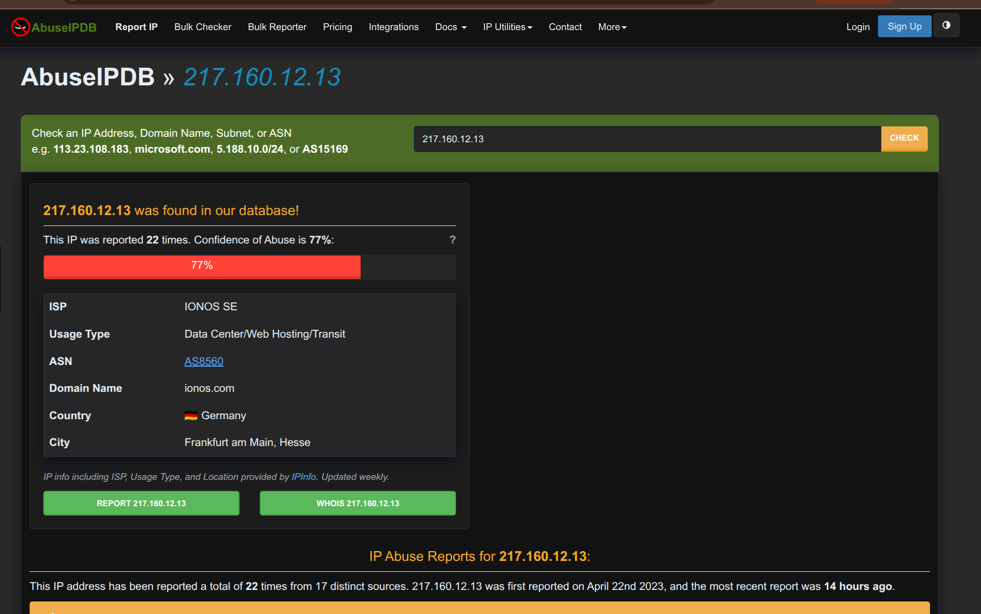
Figure 2: Searching result for 217.160.12.13 on AbuseIPDB
The page also provides information similar to what we saw in the SSH Brute Force case. This IP was identified as originating from Germany, and its confidence of abuse score was 77%. Although the score is not as high as the SSH case, but it is still relatively high and should be investigated to determine whether it is malicious IP or not.
Scroll down to the IP Abuse Reports for 217.160.12.13:
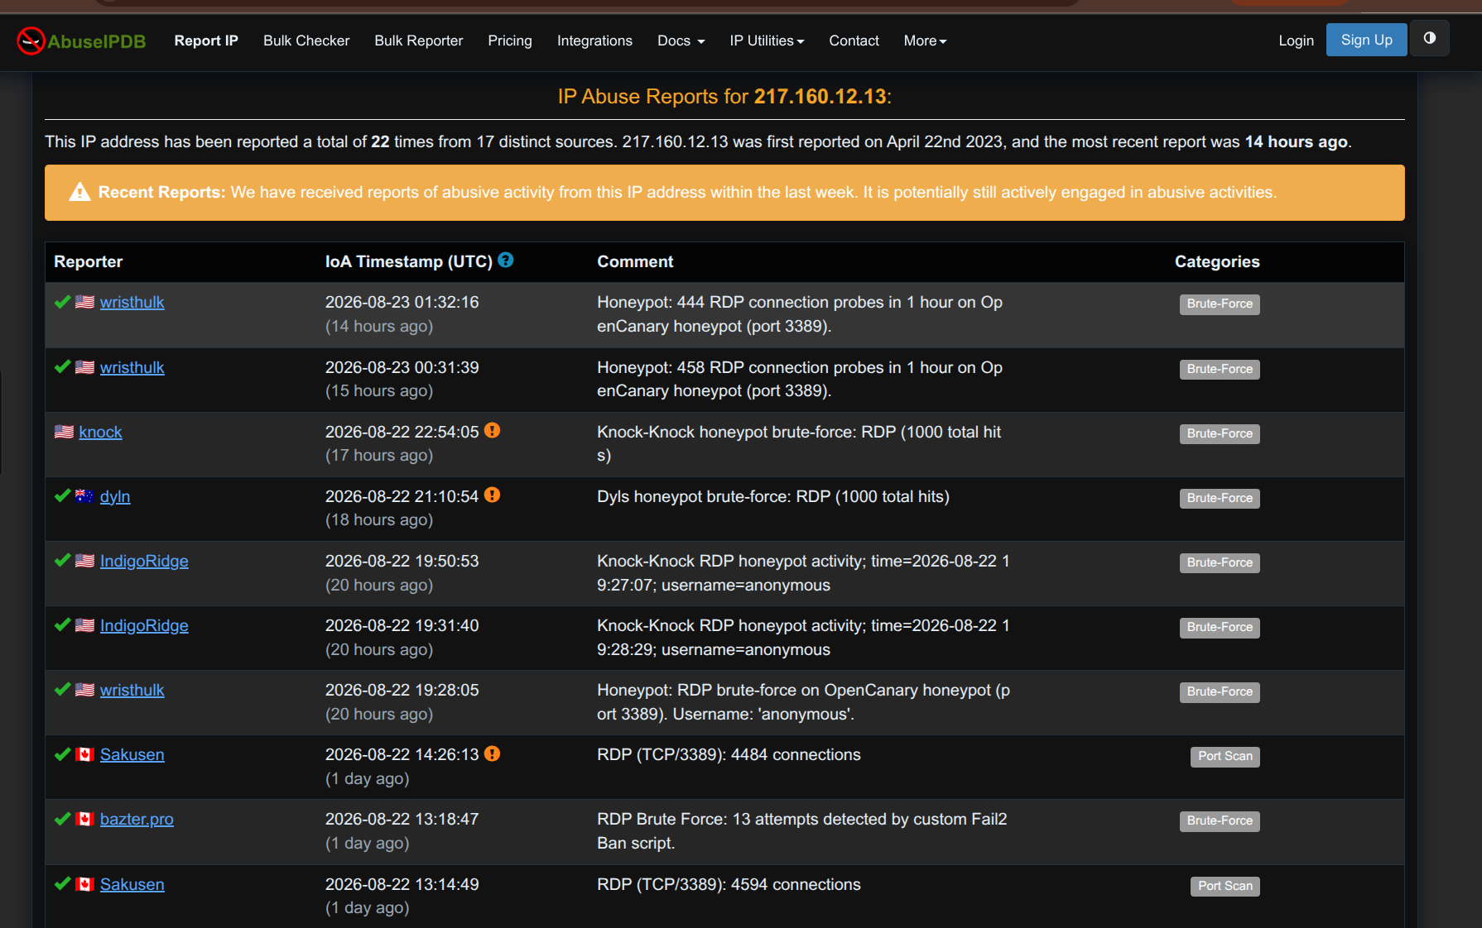
Figure 3: The IP Abuse Reports for 217.160.12.13

As shown in Figure 3, there are 22 reports about this IP and most of these reports are classified to malicious activities like Brute-Force attack or Port Scan related to RDP service.
Notable activities of this ip: Wristhulk observed the IP making 444 RDP connection probes within 1 hour against an OpenCanary honeypot, or dyln from Australia reported another RDP brute-force against their honeypot.

I also searched for this ip on GreyNoise. Now, the result is slightly different from what we saw on AbuseIPDB. This page says it hasn’t observed this IP mass-scanning the internet yet. Therefore, I want to check the IP address across multiple platforms to get a broader perspective.
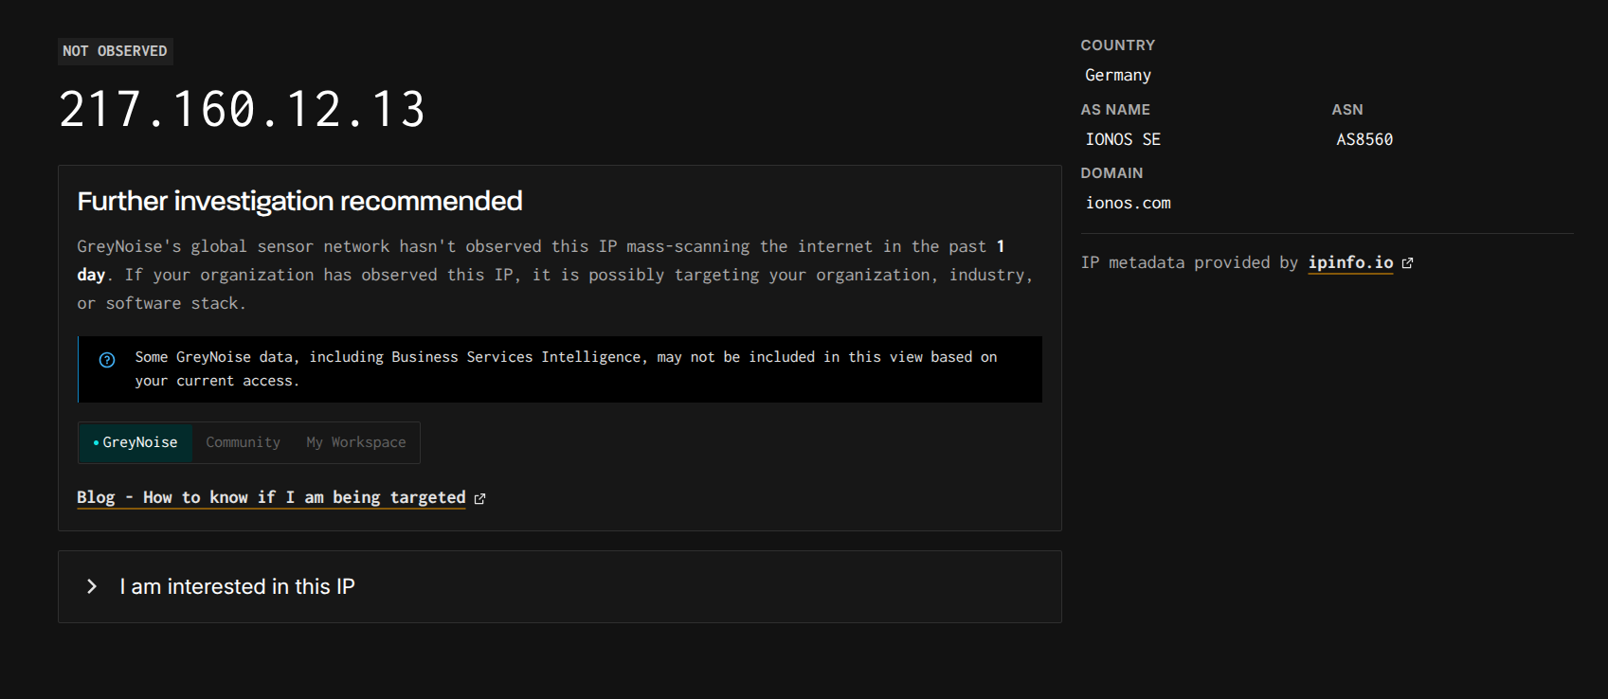
Figure 4: Search result for 217.160.12.13 on GreyNoise

Next, I want to know what username the attacker is targeting. Let’s go to the Discover tab and search for this IP to the search bar:

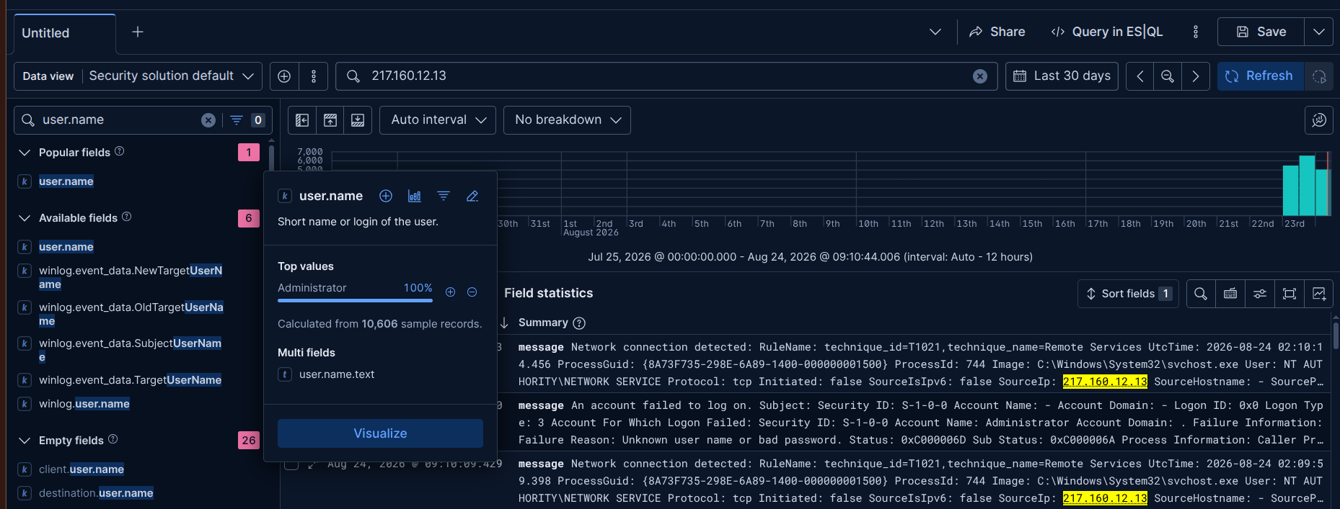
Figure 5: Target usernames attacker is attempting to get access
As shown in Figure 5, the IP address 207.160.12.13 is only targeting to the Administrator account. This case is particularly urgent because this account has a high-priviledge on the machine. We need to investigate whether the attacker successfully logged in.
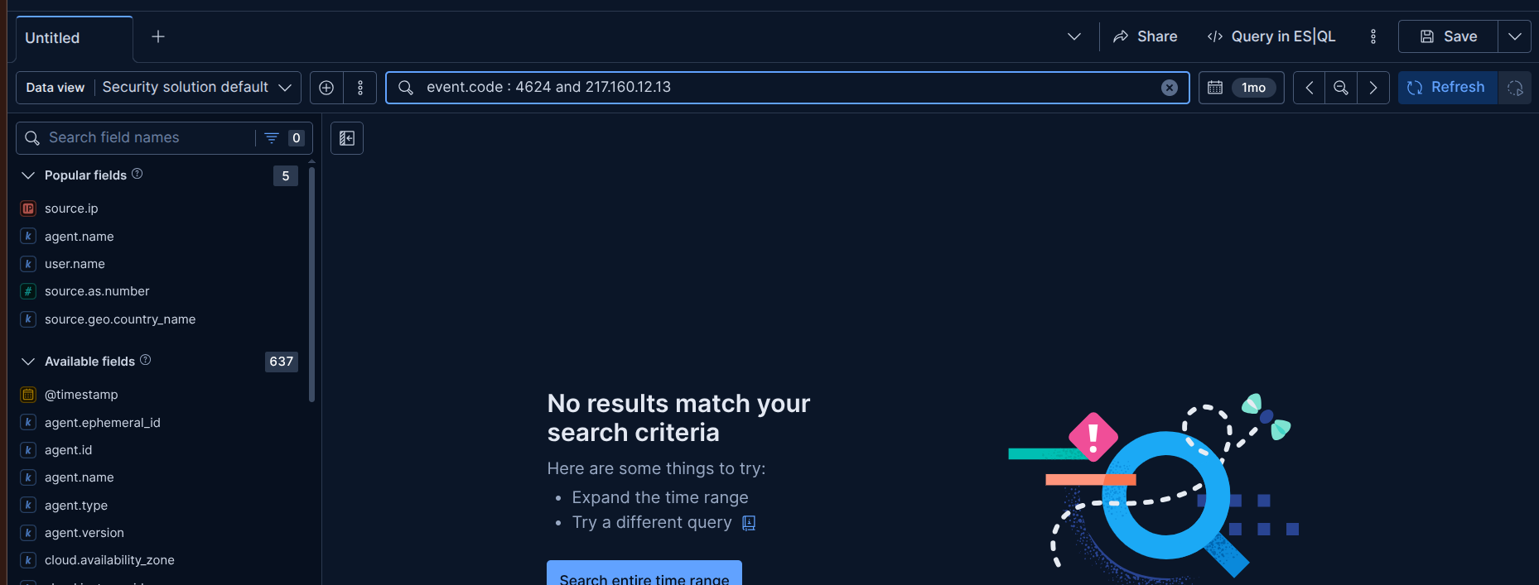
Figure 6: Looking up successful logins from the IP 217.160.12.13
Fortunately, there were no successful login events from the malicious IP.
I finished an investigation procedure of the real-world brute-force attack traffic. Now, I’ll continue analyzing the simulated attack that I performed on the Day 21 to gain a better understanding of the events related to Windows logins.

Go to Stack management >Advanced settings ( kibana entry) > Time zone and adjust display time for logs.
After that, change the time filter to range of the day occurred the simulated attack (traffic was generated from kali linux on Day 21)
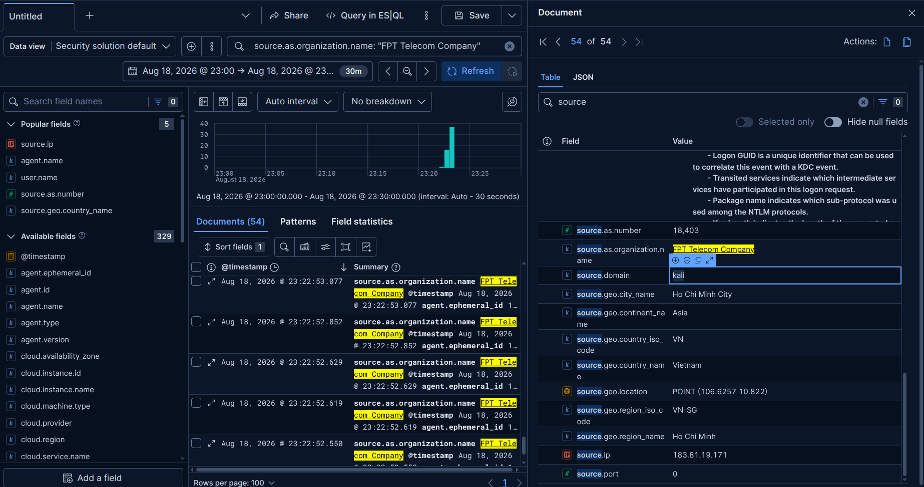
Figure 7: Searching for the simulated attack
My public ip when I performed brute-force attack to RDP service: 183.81.19.171. However, this IP can change by ISP when I reconnect to the network, so it may be different when I execute the payload.
The query:
source.as.organization.name: "FPT Telecom Company" and event.code:4624

Time range:

Aug 18, 2026, 23:00:00.000 to Aug 18, 2026, 23:30:00.000 (remember time zone is GMT+07:00 – Asia/Ho_Chi_Minh for match results from Figure 8).

I will use the field winlog.event_data.TargetLogonId to view the chain of events related to a successful login session, specially:
Whenever Windows generate a logon session (regardless of whether it is logon type 2, 3, 10,...), it always generates a hex code for that session - called Logon ID. This field usually appears under 2 different name, depend on the role of it:
- SubjectLogonId → Logon ID of the session that is PERFORMING the action (caller side).
- TargetLogonId → Logon ID of the NEW session that is GENERATED (the result of the action)
The example is get from the log in Kibana:
- Event 4624 (Type 10 - RemoteInteractive):
- SubjectLogonId: 0x3e7 ← session of SYSTEM account, which is current perform generating logon
- TargetLogonId: 0x407a3ef ← NEW session was generated for Administrator account.
→ 0x407a3ef is an unique “ID card number” of the RDP Administrator session just open. From now on, all actions that occurrs in that session like file open, process execution, session closing... will carry the Logon ID to declare which session it belongs to.

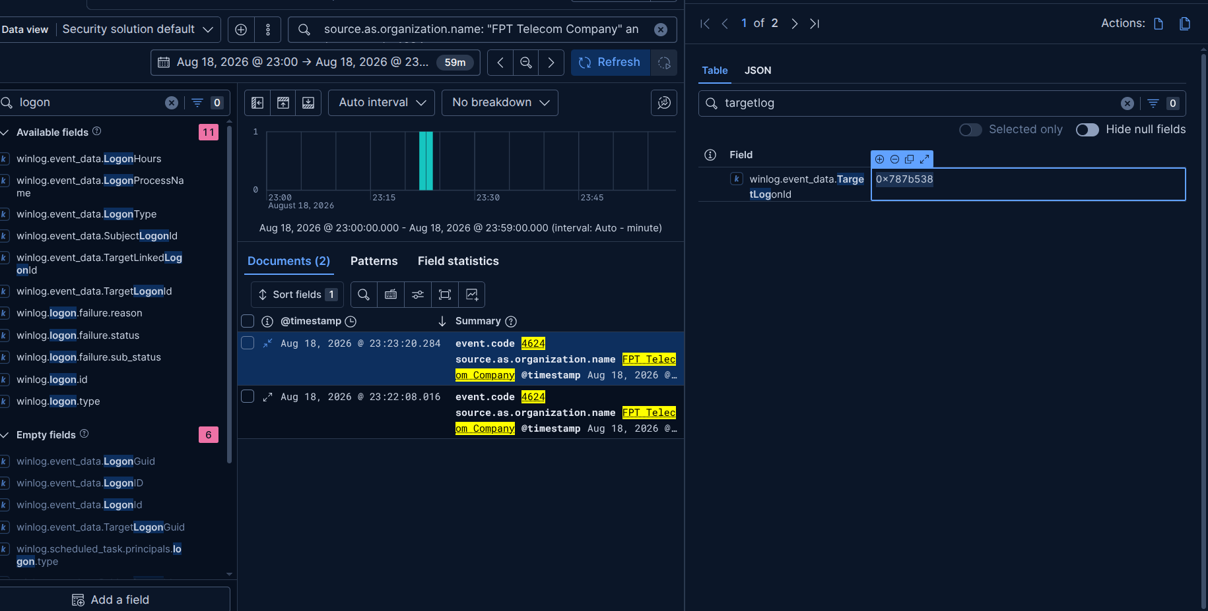
Figure 8: Logon ID of the RDP login session
Change the query with logon ID from Figure 8 to find the chain of actions in that session:
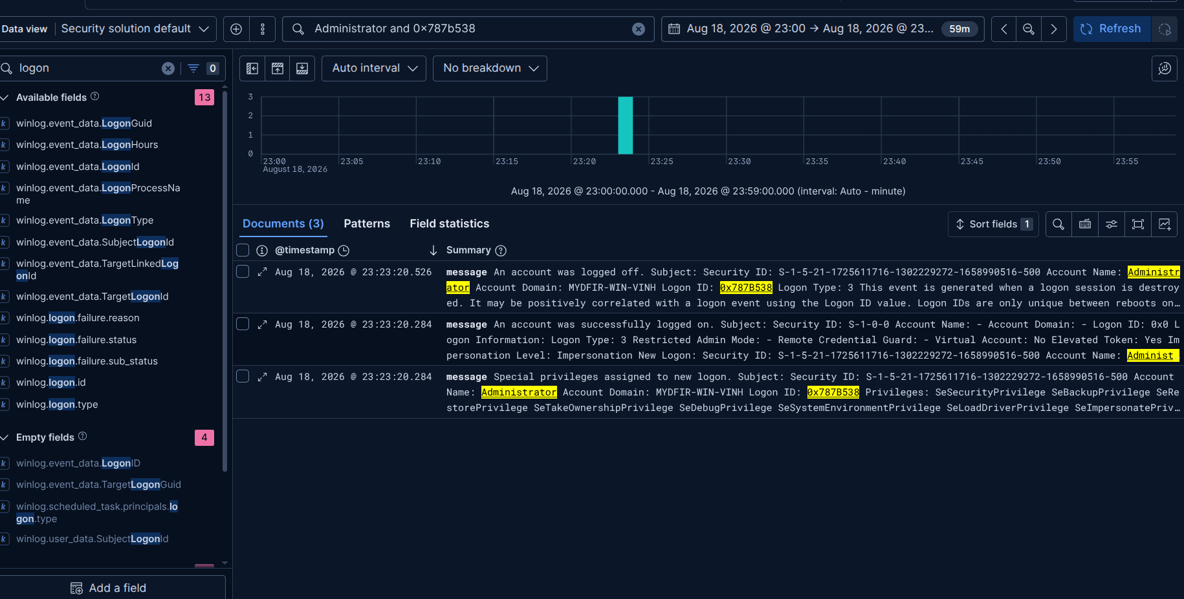
Figure 9: Occurred events in the session 0x787b538

